What do players/Coaches need to know when commencing training?

A Risk assessment for modified netball to take place can be found [here.](Ref-1.-Stage-4-risk-assessment-template-updated.docx)

A risk mitigation plan is also available [here.](Register%20for%20Re-Opening%20UPDATED%2019-08.2020.xlsx)

Please make sure you have read both before commencing netball.

* Get In, Play Safe, Get Out

This is a concept that should be adopted by all netball organisations around any activity.

Get In – arrive changed, ready to participate/coach or officiate. Arriving considerably earlier than the session or match time should be avoided.

* Participation in any training activity or match is the choice of the individual and all will be required to ‘opt in’. Please click [here](Ref-6.-Opt-In-guidance-updated.pdf) to read and sign the ‘Opt in’ declaration. Please email back this signed copy to CMONetballClub@gmail.com
* Before attending training, players must sign the ‘Opt in’ document.
* Pressure will not be placed on individuals to participate or compete if they are uncomfortable with the risks associated with netball activity
* In line with Government guidance, all players, coaches, officials, volunteers and others attending a netball activity should check themselves, and anyone else in their household, for COVID-19 symptoms before they leave for a netball activity. If they, or anyone in their household has symptoms, they should not attend
* Any participants (including coaches, officials, volunteers and others) who have been told to self isolate by NHS Test and Trace as a result of being in contact with a known COVID-19 case, must not attend any netball activity and they should remain at home. For more information on Track and trace please click [here.](Ref-11.-Test-and-Trace-in-netball-protocol-updated.pdf)
* We will follow the Test & Trace protocol in line with the NHS scheme. The information will be stored in line with GDPR guidelines for 21 days.
* Every player must use the Track and Trace QR code before training. To access the Track and Trace, please click [here.](CMO%20QR%20Code.docx)
* Players should follow latest Government guidance on travel. Click [here](mailto:https://www.gov.uk/guidance/coronavirus-covid-19-safer-travel-guidance-for-passengers) for more information.
* There will be no changing facilities available so everyone should come changed and ready to play
* Hands must be sanitised before arriving at a game.

Play Safe – safety within sessions or matches must be taken seriously by all and is the responsibility of everyone. Players should encourage and remind one another of the COVID-19 rule modifications and protocols as much as coaches and officials do.

* All players, coaches, officials and volunteers must go through a health screening as they arrive. They should not mix with others until this is completed. The health screening will be carried out at all netball activity (training sessions and matches) and screens for COVID-19 symptoms. Click [here](Ref-5a-Health-screening-updated.pdf) for the COVID-19 Health Checker.
* All training and matches (both friendly and competitive) must be played in line with the COVID-19 rule modifications. See below for rule modifications.
* All involved in netball activity must be aware of all COVID-19 rule modifications before they participate in any activity
* Coaches must support umpires by reminding players of the COVID-19 rule modifications during any coaching practices or matches
* Shouting should not take place by coaches or spectators during netball activity as this increases the risk of COVID-19 transmission
* Time must be planned into every session for ball and hand sanitisation at least every 15 minutes
* Make sure water bottles are labelled and not shared.
* Follow this [link](Player-Education-infographics-002-4.pdf) to understand the personal risks to you.

The following must not take place during any training sessions or netball matches;

* Nail checks should take place at a distance of 2m or more
* There should be no pre match huddle – players should remain socially distanced for any pre match team talk
* No pre match or pre quarter hands in
* No shouting or cheering
* No quarter or half time huddles
* No high fiving
* No post match hug circles or handshakes
* Any post match paperwork should be shared digitally (this could be emails or photographs)
* No post match team teas or sharing of snacks and confectionery

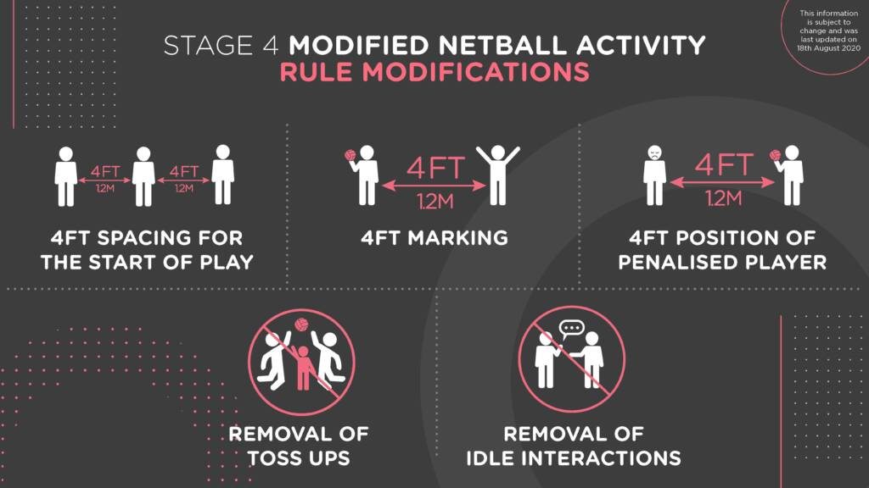

For a more detailed discussion of the rule modification, please click [here.](mailto:https://www.youtube.com/watch?reload=9&v=qDrsID6QtCw&feature=youtu.be)

Get out – At the end of any activity all players, coaches, officials and others should clear the court/area straight away and should not congregate at the edge of courts at the venue and should shower/change back home.

* All equipment must be sanitised after all netball activity, including netballs, bibs, netball posts and other items such as spots, ladders and cones
* All players, coaches, officials and other attendees must sanitise their hands as they leave
* Any attendee who develops COIVD-19 symptoms up to 48 hours after any netball activity must report to NHS Test and Trace and notify the COVID Officer if the test is positive

Please remember to maintain social distancing. Click [here](Social-distancing.pdf) for more info.

Personal Risk assessment

For personal risk assessment please click [here](Ref-13.-Personal-risk-assessment-final.pdf)

Higher risk groups

Self-isolating -Nobody in this group will be able to leave their home to access sport and physical activity opportunities.

Shielding and clinically extremely vulnerable- People in this group are defined, on medical grounds, as clinically extremely vulnerable to COVID-19 – that is, people with specific serious health conditions - and who have been advised to ‘shield’

Clinically vulnerable -Although this group can meet people outdoors and take part in physical activity and exercise, they should be especially careful and diligent about social distancing and hand hygiene.

Moderately at risk- If members are 60+, male, lower-socio economic status or from a Black, Asian or minority ethnic background, they are more likely to get seriously ill from coronavirus.

Everyone else -Anyone who isn't in one of these groups will be able to access all available opportunities. For latest government info, see: www.nhs.uk/conditions/coronavirus-covid-19/people-at-higher-risk/ who’s-at-higher-risk-from-coronavirus/

Managing any concerns and breaches in this guidance

This guidance is put in place to enable netball to return to court whilst mitigating the risks associated with it. Local netball organisations will be responsible for ensuring they adhere to national and local government guidance as well as all England Netball guidance. COVID-19 Officers should regularly review the risk assessment in line with any updated guidance. England Netball will take seriously any breaches of this guidance. Initially any concerns should be reported to one of the following;

• COVID-19 Officer • Club Safeguarding Officer • Other appropriate committee member